DBMS Lab – 3

**View and Visualize all kind of joins**

**View the table**

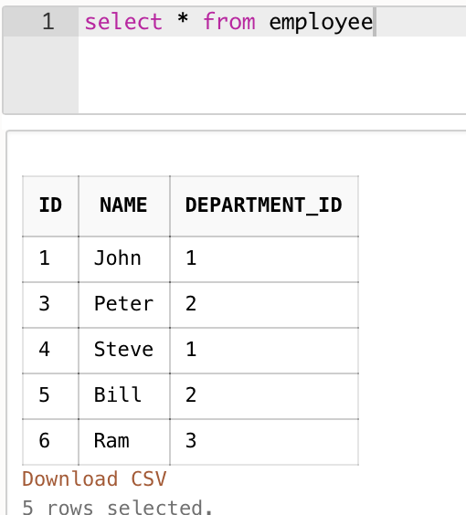

**Outer Join**

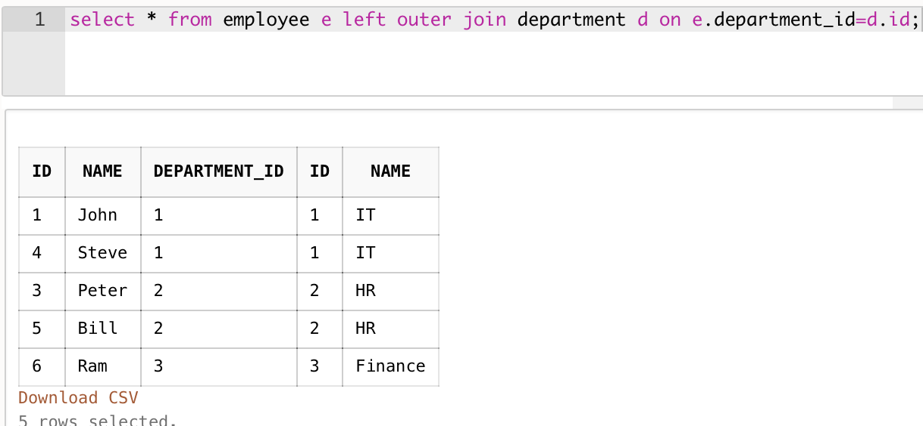

**Inner Join**

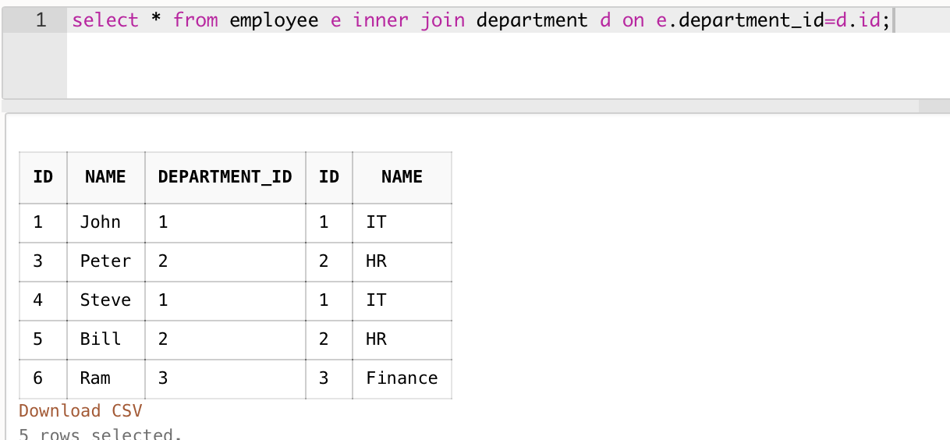

**Cross Join**

